Week 1 questions

Task 0
Asda 9.232
Sainsbury 13.565
Tesco 6.456

Task 1
1. The independent variable in this experiment is the website that are being searched on.
2. The dependent variable in this experiment is the time taken to find the desired biscuit

3. I hypothesize that Sainsburys will take the longest to find due to the fact that the search bar on their site blends into the background. I would say this is because the search bar has no outline. It only gets an outline when the user clicks on the search box. The format of the header of each website are similar but Asda has the highest degree of clear separation between its elements. I also noticed that the search bars for the Tesco and Sainsbury are on the opposite side from their main logos where as Asda has their search bar beside their logo. Since the logo is usually the first thing that a user will focus on and having the search bar be the closest thing to the logo speeds up the recognition by the user. So if having the search bar close to the logo theoretically speeds up the search time having the search bar far away from the logo there for should there for lead to a slower search time for Tesco and Sainsbury.
The action of searching for a product appears to be the same for all the sites. I.E type the name of the food stuff you’re looking for and press enter. Once results are found they are displayed in a grid view on all the sites however the size of the boxes in the gird are different. With Asda the boxes are thin and sandwiched together making the grid look busy possibly making it hard to find a specific item. On the other hand with Tesco and Sainsburys the boxes have padding in between beach box making each element clear and easier to recognise what every item is. Also Tesco and Sainsburys have a darker grey background making contrast that makes the lighter elements clearer and easier to make out.

Task 2
- 62 participants are in this data set
- Asda mean 18.07198 Sainsbury mean 7.63800
- Asda sd 10.563304 Sainsbury sd 3.087011
- P value <0.01
- By having a p value of <0.01 we can reject the null hypothesis in this case that there is no difference between the websites. Hence there is a notable difference between the search times on both websites.

Week 2

Task 1
1.The term within-subject design refers to a type of design for scientific experiments wherein the participant doing the test completes all the conditions of a given test. This means that the participant becomes a constant in the experiment. An example of this would be if you wanted to test user interaction on a new mobile device. If the test is in a controlled environment the one user would test every version of the device to do a specific task. i.e., software or hardware. The at the end the participant give a rating from 1 to 10 on how easy they felt the given task was to complete.

One study that could use the within subject design is A comparison of voice controlled and mouse-controlled web browsing. In this experiment 18 participants compared voice browsing with the usual mouse-based browsing. This was then continued to test which of the three most common types of hyperlink forms where the most voice browser friendly. The independent variables for the experiment was the style of navigation being used (i.e. voice control) and the dependent variable is the time taken to complete the given tasks. The study found that “voice control adds approximately 50% to the performance time for certain types of tasks” and that most motor-impaired users who speak English without an accent will be able to use voice control to navigate the World Wide Web. The procedure for the experiment was that when the participants were given a brief example of how to use the voice control feature, when they are ready to start, they were given a list of tasks to complete using the voice control. The timer would stop when the participant returns to the home page. One test observer would note down any mistakes that were made. The hyperlink forms that were tested used words or numbers.

2. The term “Normal Distribution” describes the phenomenon that happens when a group of values gather around one main point and distribute around the point evenly. Giving no bise to ether side. The central point that the value gather around can be the median, mean or mode. A set of data can only be said to have a normal distribution if the results lie 50 50 around the point and it makes a sloping shape. If a set of data that is normally distributed it can be said that if the test was run again the result would likely appear within one standard deviation from the central point.

Task 2
1.
Comparisons | P value
Asda vs Sainsbury | 0.055
Asda vs Tesco | 0.454
Sainsbury vs Asda | 0.137

2. with the p – values that have been calculated all of them are >p some by large margin this means that there is no significance difference between the sites being searched on.
3. null hypothesis – there is no statistical difference between the core search pattern of the websites
Alternative Hypothesis - there is a difference between the recognition time of the participant doing the experiment.
4. The Wilcoxon signed rank testis best used when the value being measured are definite e.g., a 1 to 10 type survey, a percentage or a strongly agree or strongly disagree type surveys. This type of test is to be used when the result being measured is observational e.g., the time taken to do a task, the melting point of metals or the fitness level of an Olympic athlete. A good example of this kind of test is seeing wither a trading course in a new subject has improved a user’s skills. Take a child and test their spelling ability then give them a 6-week spelling course and test the child again. To see if the course helped them improve.
5. I think that the outliers should be left alone before the test because the main factor of a Wilcoxon signed rank test is the fact that the median is being used in every calculation. I think that since the median is being used a single outlier would not influence the median very much because the median is the middle value of a group of results. If the test used the average then yes the outliers should be removed because the stray result could influence the average negatively in the final view. However, if there are a small group outliers spread throughout the data that could move the median around.

Week 3
Task 1
The questions I have made are

For every question highlight you answer
1 Do you agree to fill out this small survey?
Yes No
2 Do you have previous experience with using online shopping spaces?
(1= strongly disagree 7 = strongly agree)
1 2 3 4 5 6 7
3 How would you rate the website being used in terms of ease of searching for a specific product?
(1 = extremely difficult to use 2 = very difficult to use 3 = difficult to use 4 = ok to use 5 = easy to use 6 = very easy to use 7 = extremely easy to use)
1 2 3 4 5 6 7
4 Was the websites interface clear and understandable?
(1 = extremely difficult to understand 2 = very difficult to understand 3 = difficult to use 4 = understandable 5 = clear to use 6 = very clear to use 7 = extremely clear to use)
1 2 3 4 5 6 7
5 Please tell us if you encountered any issues while using the website?

With the first questions I first needed to get the participants knowledgeable consent to taking the survey and using the data held within their answers. This is to conform to data laws. For the second test I wanted to see a baseline for the average level of knowledge about using online shopping or experience traversing websites. By doing this we can see what a wide range of people experience while using the website. For the third question I get into the main question of the survey to get the level of usability for the websites. This question asks one of the three main aspects of usability “effectiveness” with this I can see if the websites are working as the participants expect. With the fourth question I asked the participant about the interface aka how the user reacts to using the system. This is called the user satisfaction, and this is the arguably the biggest part of a website’s usability. With is I can see how the user feels about the website as a whole. For the final question I asked the open-ended question about any issues the participants may how found while using the website. I made the question with out a word count so the participant can be as specific or as vague as they can be.

Task 2
1

Question | Response one | Response two
I think that I would like to use this system frequently? | 2 | 2
I found the system unnecessarily complex | 1 | 1
I thought the system was easy to use | 4 | 5
I think that I would need the support of a technical person to be able to use this system | 1 | 1
I found the various functions in this system were well integrated | 3 | 4
I thought there was too much inconsistency in this system | 2 | 1
I would imagine that most people would learn to use this system very quickly | 5 | 4
I found the system very cumbersome to use | 2 | 2
I felt very confident using the system | 5 | 3
I needed to learn a lot of things before I could get going with this system | 4 | 1
Total score | 29 | 32
SUS score | 72.5 | 80

2 p value = 0.23
Since the p value is above 0.05 we can conclude that there is no statistical difference between the two SUS scores
I decided to use the Wilcoxon signed rank test to test this data because the data being tested is ordinal specifically a Likert type survey
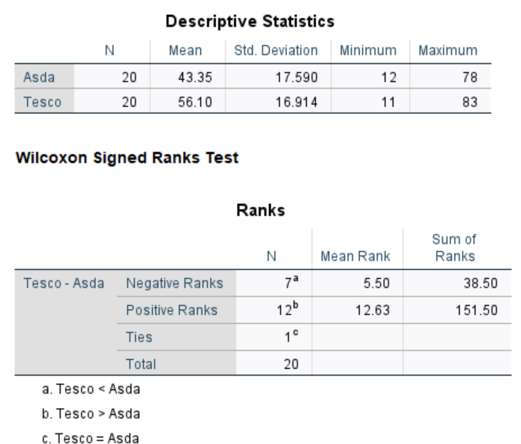
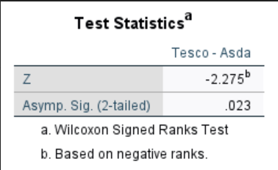

Null – there is no difference in using ether website.
Alternative – which website would the average user prefer to use.

3 The Cronbach’s Alpha for the given set of data is 0.739. Since this value is above 0.7 this data set can be said to have a sufficient measure of consistency hence this set of questions is a good survey. If I wanted to increase the Cronbach’s Alpha value I would remove the complexity question. This is because the average intercorrelation for this value is low hence dragging down all the other average’s. Leading to a lower score over all

Week 4
Task 1

- For this question I have chosen to use the example of the drop-down menu on the amazon home page. The first aspect I would like to focus on is the grouping of elements or the law of Common Region. This law is in effect because the group of elements are boxed in using lines as a barrier between the groups. The designer also used the law of Proximity by grouping similar menu options together such as grouping the help and general settings together or grouping the departments of different products together. It can also be said to follow the Laws of Similarity not by shape of the options but by the same font used by all the options. This also applies to the font size as well having the heading of each group in bold for clearly show the start of a new group. As well as having the sub options the same size and font reinforces the concept of them being grouped together.

Website in question : https://www.amazon.co.uk/?tag=tochibauk-win7-ie-portal-bro-21
Element in question is the dropdown menu on the far left of the screen.

- 1.when trying to adjust the volume on a tablet I would expect to find the volume controls on the side of the tablet. I would expect the controls to be grouped together with the volume up controls to be the button on top and the volume down button to be on the bottom. I would expect this because this layout is widely used in all types of volume controls such as a tv remote. This is because this button configuration makes sense logically volume up being “up” and volume down being “down”. This form of logic can be explained as people associates something getting bigger with getting taller like a tree. This layout could be reversed but only if the controls are ladled correctly. Such as a up with a + and down with a – or with the more explicitly vol up vol down.

- When turning the page on a tablet the average person would expect something like reading a book in real life. Such as turning a page to go forward would move to the “right” in the western world or to the left in the far east. This would be further explained in how each language the read left to right in English and right to left in Japanese For this to work on a tablet I would expect that swiping from left to right would move the book forward and to swipe right to left in order to move backwards through the book. The action of swiping in this sense would then digitally rep resents the action of turning the page in the real physical world. By making this link the average user should instinctively know how to move around a digital book as well as they would with a book in their hands.

- when scrolling through a playlist on a smart phone I would expect that that swiping form up to down would move the playlist up and then making the opposite motion would do the opposite move the playlist down. Actions can be explained by the real-life act of opening and closing blinds. When pull down on the string the blinds will open and when you pull the other string up the blinds will close. The horizontal roller blinds are closer to the act of navigating a playlist on a smart phone. In this logical framework bottom of the blind is the point in the playlist that a user can see and swiping up and down on the phones touch screen will move the view up and down the playlist. In this framework the playlist is like a long piece of paper. So, the action of swiping would react like a person changing which point the person is looking at on the long page.

- The triggers on a video game controller have been used to represent lots of things the main two are the trigger of a gun or the pedals of a car. When using the trigger as a way of controlling a car the trigger becomes analogous to the accelerator pedal in a real car. When driving a car in real life the driver presses down on the accelerator pedal to speed up and ease up on a pedal to stop adding speed. This can be directly applied to the trigger on a controller since a trigger can give adjustable input form the player. This way a player can control how much the car accelerates and brakes just like driving a real life. So the connecting logic here is the action of pressing down on a pedal to have a big effect on the object being controlled.

- I would assign the rings as such

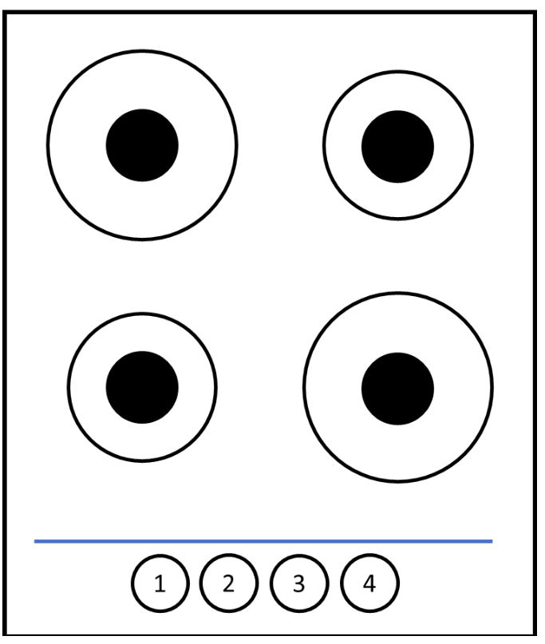
I would use this assignment due to the concept used in the written English language reading from left to right then go back to the left at the end of each line. I would do it this way because it would be following a known logic predominantly for most of the western world. Also, with this layout the first button would turn on one of the biggest rings which would be easily noticed when it would be turned on. The same can be said for the fourth and final button. Since all the rings on the hop are one of two sizes so the ordering cannot be based off the size of the rings. Another way of ordering the rings would be by position I.E 1 would be lower left, 2 top left, 3 top right 4 lower right.

Task 2
- I believe that the main source of problems for a deaf person shopping would be at the checkout. Both forms of check out have their own issues. To start off at a normal checkout a deaf person would have trouble communicating with the cashier. The problems would arise when the options of coupons or any gift cards. The deaf person would have problems getting their choices across. These problems are solved when using a self-service checkout since the display would show every option available to the user. There is a new problem however some self-service machines have weight measuring area for items that have just been scanned. The problem is that this is usually only announced vocally by the machine. A deaf person would not hear this and would get errors with out knowing why. Another issue can arise when a deaf person can’t find a specific item and must ask a member of staff for help leading to inevitable communication problems.

- I would order the cutlery by usability for a blind person as: C, D, B, A. I would say C is the best because each individual utensil has their own unique texture and shape making them easy for a blind person to differentiate. D is second because they again have a unique shape making them slightly easier to differentiate. C is third because they have a distinct texture. However, since the texture is uniform for both pieces of cutlery it is imposable to identify the utensil just by the handle. A is last because they have no distinct shape of texture to identify the utensil

Week 5
Task 1
Part 1 The main users of the preposed system will most likely be university students. So aged between 18- 25 years old, to be sufficiently academically minded in order to get in to a university and being born in the last two decades it would be fair to say that they are it literate.
The main two forms of user activity are interaction and manipulation. Being as this is a is going to be a user interface for a mobile phone app there is going to be swiping and gesturing on a touch screen. As for the manipulation the user can interact with calendars (zooming in for clarity).

I believe that the device that the user will use to access this application will be smart phone.
if the user is using a phone it would most likely be hand held so small.
Since students will be using this, I believe that the application will be used in the afternoon and would be used in their dorm room/flat or at a library.

The main constraints when designing an app for a smartphone are the small screen size and the smaller computing power when compared to desktop computers
I believe that the user would be using there full attention in or der to navigate the app and to understand what function is right for them.
The system should be Transient. This is because the system takes dates and times in order to make a meeting. Taking in info and then sending it on transient.
The system should be as close to instant as posable to instant for navigating the system and for sending emails.

Since this is going to be a smartphone app the main form of input will naturally be the touch screen.
Other inputs may include voice commands or keypads for disability access.

Step 2
The two essentials’ elements needed for this app are calendars and staff information. The main ways to interact with these two elements are to swipe on the touch screen to navigate the calendar and to navigate to the staff information.

The main two webs standards that I will keep in mind when designing the application are the w3c standards on web application on mobiles. Also, the a11y standards on web application accessibility. I will focus on the w3c standards to make an application that meets the expected international standards. Then I will use the a11y standards in order to make the application assessable to as many different kinds of people as posable.

W3c (January 2015) Standards for Web Applications on Mobile: current state and roadmap
Available at: https://www.w3.org/2015/01/mobile-web-app-state/ (Accessed: 28 February 2022).
A11y project(no date) CHECK YOUR WCAG COMPLIANCE Available at: https://www.a11yproject.com/checklist/ (Accessed: 28 February 2022).

I believe that the most important design principles is reduce distractions. I thinks this is important because to the average user if they cant figure out how to work a given system they will just give up and never use it again. For a system to be successful they need to be a simple and follow a simple process so the user can be satisfied and kept happy.
Interaction design foundation (no date) Design Principles Available at: https://www.interaction-design.org/literature/topics/design-principles (Accessed: 28 February 2022).

A design pattern that I think would be useful to my application is the event calendar shown on the website UI-patterns.com. I believe that this would be useful for showing availability for meetings. So instead of showing dates and times for parties and events the calendar would instead show what member of staff is available on what day. This would allow a user to navigate to a day that they are available and to see if the right person for them is available on that day. This is just one way of showing the user clearly the information that they require.

Ui Patterns (no date) Event Calendar Design Pattern
Available at: https://ui-patterns.com/patterns/NavigationTabs (Accessed: 28 February 2022).

Step 3
One what if question is “what if I need an emergency meeting and can’t get another meeting until next week?” this would be a problem since one of the staff works with mental health. If one of their clients has a mental breakdown and needs help as soon as posable. To solve this, I would have a section for the mental health staff member that is solely for emergency only and leave a space of time in his schedules for these emergency meetings.

Task 2
Step 1
The three user goals that I want to achieve with this application are to be helpful, useable, and efficient.
- I want the application to be helpful because the students coming to the application for a certain solution, and I want the student to leave the application happy knowing that they have found the help that they need.
- The application needs to be simple to use since the users are coming to the application with a problem the last thing, they need is more problems when they just need a quick solution so they can leave the application at ease.
- Lastly the application needs to be efficient since the user is looking for a quick setting up of a meeting to get help if the system takes too long to function, they could miss out on an essential opportunity to get help. They application should leave the user at ease knowing that they can get the help they need.

Step 2
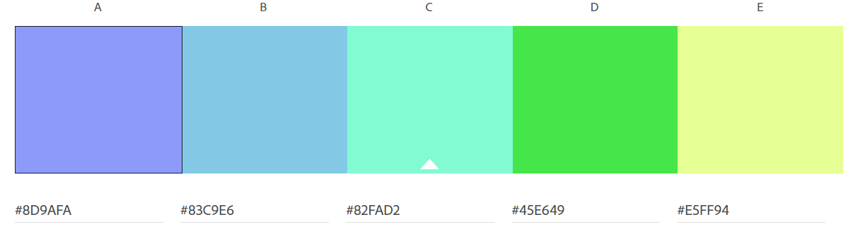
This is my chosen colour pallet. I have chosen to use a subdued colour pallet since it has been shown that cooler more subdued colours help to put the mind at ease (Karla Gutierrez no date). Which is helpful since the users are coming here because of stress and other problems this will help to calm them down a bit while using the site. It has been shown that lighter shades of blue can aide in concentration (Karla Gutierrez no date) so using these colours will help the user to concentrate and calmly find the right person to get help from. The use of green will also help the user to relax due to greens relaxing effect on the human mind (Innova 17 December 2014) and since there is a mental help section by using green here will help the user quickly find it if they are looking for medical help (mental health treatments).

Shift Learning Karla Gutierrez (no date) Color Psychology: Use Cool Colors to Set Just the Right Mood for Learning Available at: https://www.shiftelearning.com/blog/color-psychology-elearning-part2
(Accessed: 28 February 2022).

Innova Design Group Innova (17 December 2014) Can colour choice in classroom design has an effect on student behaviour? Available at: https://www.shiftelearning.com/blog/how-do-colors-influence-learning (Accessed: 7 March 2022).

